- 2.1 Classification of the substance or mixture
- Classification according to Regulation (EC) No 1272/2008

flame

Flam. Liq. 2 H225 Highly flammable liquid and vapour.
health hazard
Repr. 2
STOT RE 2
Asp. Tox. 1
H361d Suspected of damaging the unborn child.
H373
H304
May cause damage to organs through prolonged or repeated exposure.
May be fatal if swallowed and enters airways.
Skin Irrit. 2 H315 Causes skin irritation.
Eye Irrit. 2 H319 Causes serious eye irritation. STOT SE 3 H336 May cause drowsiness or dizziness.
SECTION 1: Identification of the substance/mixture and of the company/undertaking
- 1.1 Product identifier
- Trade name: Mould Cleaner Wipes
- Article number:
Wipes_Mouldclean 9312
- CAS Number: Formulated blend

EU Registration number
All substances used in this mixture have been notified or registered under the UK REACH regulations, see below for further details. Refer to our office if you require additional information.
For UK REACH, a Downstram User declaration (DUIN) has been made, or a registration is in the process of being made within the timescales specified in the regulations based upon import volumes.
For UK REACH - please refer to our office to confirm substance registration.with regard to exports to EU markets.

1.2 Relevant identified uses of the substance or mixture and uses advised against
No further relevant information available.
- Application of the substance / the mixture Cleaning wipe

Uses advised against
Food contact, additive.
Not for mixing/formulation by public/consumer. Industrial only.

1.3 Details of the supplier of the safety data sheet
- Supplier:
Adamtech Ltd T/A Specialty Wipes
7B Whitebridge Estate
Stone
Staffordshire ST15 8LQ
Tel.: 01785 286660
Fax.: 01785 286661
email:sales@adamtech.co.uk
Further information obtainable from: Contact us at the above office.
- 1.4 Emergency telephone number: Contact us as above (Not 24 hours)

SECTION 2: Hazards identification

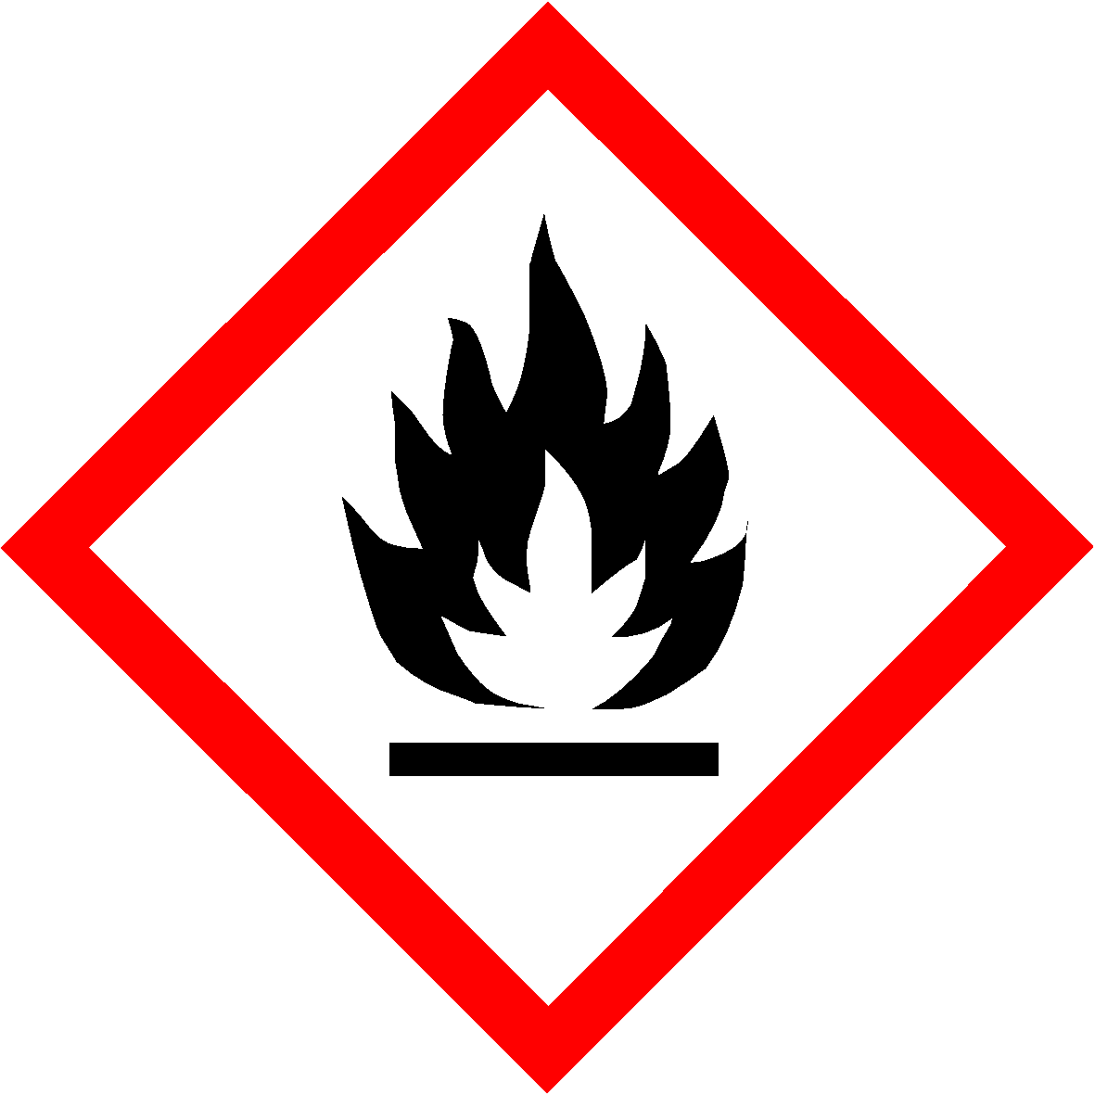

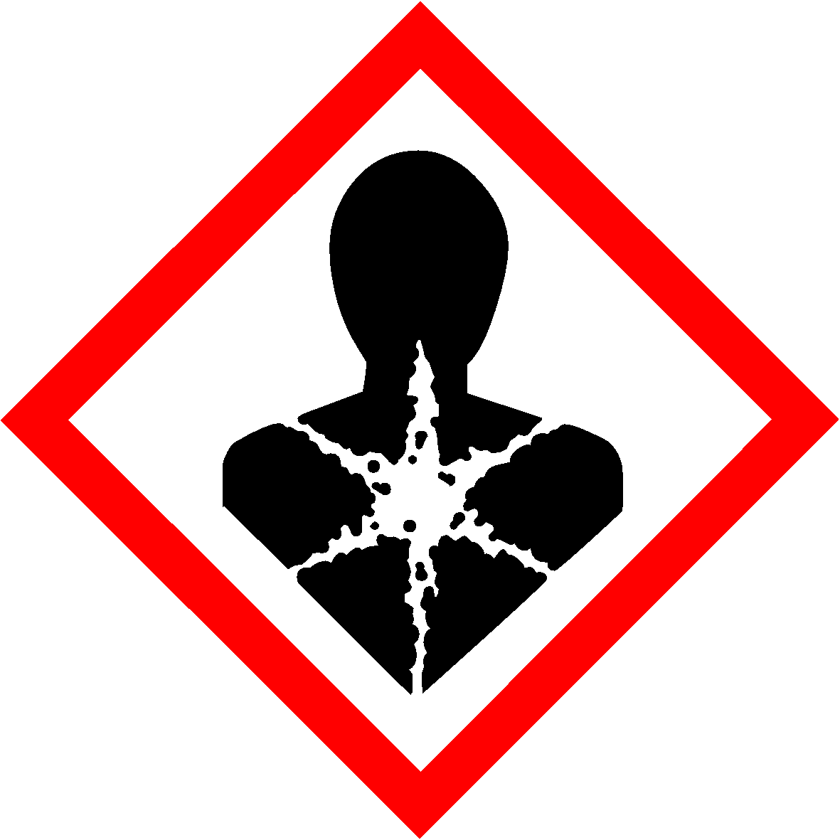

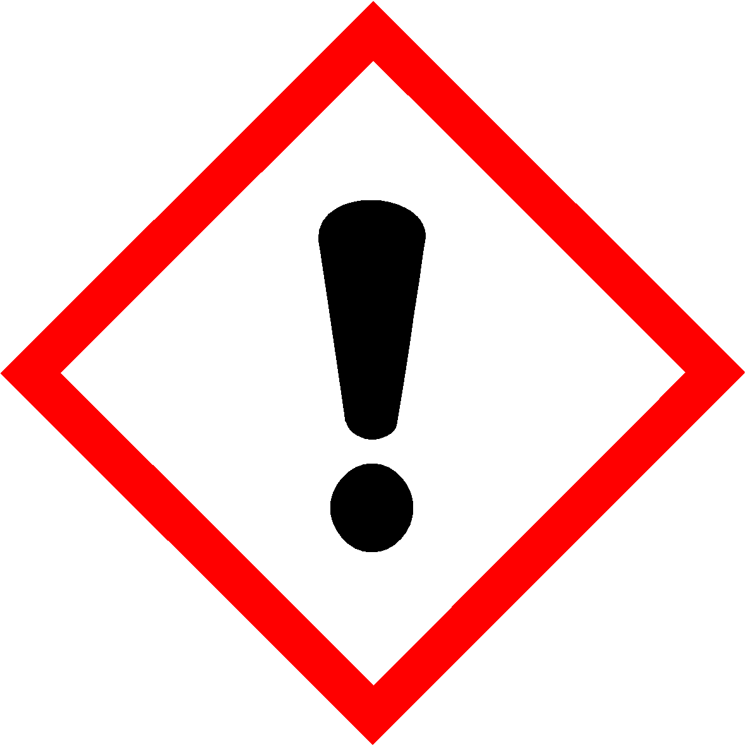

- 3.2 Chemical characterisation: Mixtures
- Description: Mixture of substances listed below with nonhazardous additions.

- 2.2 Label elements
- Labelling according to Regulation (EC) No 1272/2008
The product is classified and labelled according to the GB CLP regulation.
- Hazard pictograms

GHS02 GHS07 GHS08

- Signal word Danger
- Hazard-determining components of labelling:
Toluene
REACH Reg No. 01-2119471310-51-XXXX
Naphtha (petroleum), hydrotreated heavy REACH Reg No. 01-2119463258-33
butanone
REACH Reg No. 01-2119457290-43-XXXX
- Hazard statements
H225 Highly flammable liquid and vapour. H315 Causes skin irritation.
H319 Causes serious eye irritation.
H361d Suspected of damaging the unborn child. H336 May cause drowsiness or dizziness.
H373 May cause damage to organs through prolonged or repeated exposure. H304 May be fatal if swallowed and enters airways.
- Precautionary statements
P210 Keep away from heat, hot surfaces, sparks, open flames and other ignition sources. No smoking.
P243 Take action to prevent static discharges.
P280 Wear protective gloves/protective clothing/eye protection/face protection/hearing protection.
P301+P310 IF SWALLOWED: Immediately call a POISON CENTER/ doctor. P321 Specific treatment (see on this label).
P331 Do NOT induce vomiting.
P303+P361+P353 IF ON SKIN (or hair): Take off immediately all contaminated clothing. Rinse skin with water [or shower].
P304+P340 IF INHALED: Remove person to fresh air and keep comfortable for breathing.
P305+P351+P338 IF IN EYES: Rinse cautiously with water for several minutes. Remove contact lenses, if present and easy to do. Continue rinsing.
P362+P364 Take off contaminated clothing and wash it before reuse. P403+P235 Store in a well-ventilated place. Keep cool.
- 2.3 Other hazards
- Results of PBT and vPvB assessment
- PBT: Not applicable.
- vPvB: Not applicable.

SECTION 3: Composition/information on ingredients

· Dangerous components:
CAS: 78-93-3 | butanone | 25-50%
EINECS: 201-159-0 | 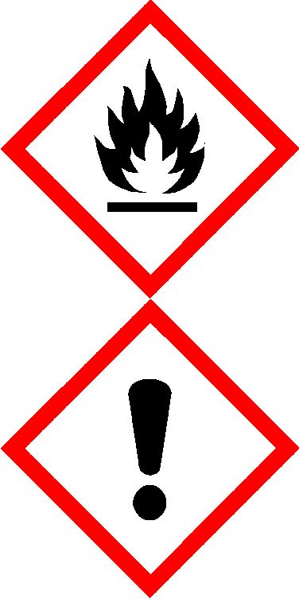  REACH Reg No. 01-2119457290-43-XXXX
 | Flam. Liq. 2, H225
 | Eye Irrit. 2, H319; STOT SE 3, H336

CAS: 64742-48-9 | Naphtha (petroleum), hydrotreated heavy | 25-50%
EINECS: 265-150-3 | 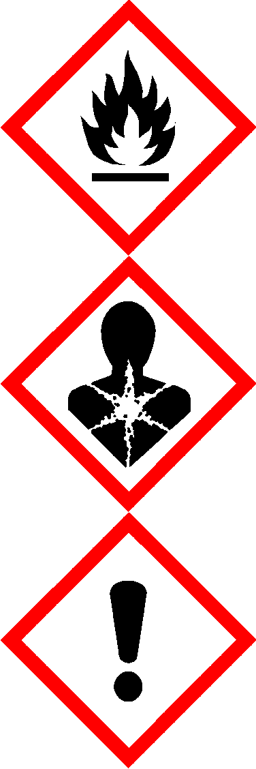  REACH Reg No. 01-2119463258-33
 | Flam. Liq. 3, H226
 | Asp. Tox. 1, H304
 | STOT SE 3, H336
CAS: 108-88-3 | Toluene | 25-50%
EINECS: 203-625-9 | REACH Reg No. 01-2119471310-51-XXXX
 | Flam. Liq. 2, H225
 | Repr. 2, H361d; STOT RE 2, H373; Asp. Tox. 1, H304
 | Skin Irrit. 2, H315; STOT SE 3, H336

SECTION 4: First aid measures

4.1 Description of first aid measures

- SVHC
Not listed as an SVHC at the date of this document.
No component (to the current best of our knowledge) is listed as a SVHC. Please refer to ECHA website.
- Additional information: For the wording of the listed hazard phrases refer to section 16.
- General information:
Immediately remove any clothing soiled by the product. If liquid has completely soked through garments to skin, wash skin thoroughly with mild soap and water. Treat soaked clothing as hazardous waste and observe all precautions for the substances.

After inhalation:
In case of unconsciousness place patient stably in side position for transportation.
Supply fresh air. If required, provide artificial respiration. Keep patient warm. Consult doctor if symptoms persist.
Seek medical treatment, if any signs of impaired recovery or behaviour.

After skin contact:
Immediately wash with water and soap and rinse thoroughly. Remove contaminated clothing. Dispose of contaminated clothing as hazardous waste. Observe precautions.
If skin irritation continues, consult a doctor.
Repeated skin contact may result in irritation and dermatitis. Always wear protective gloves suitable for this product.

After eye contact:
Rinse opened eye for at least 15 minutes under clean running water. Remove contact lenses if possible. Seek immediate medical advice.
Continue to irrigate the eye with clean water. Seek immediate medical advice.
- After swallowing: Do NOT induce vomiting; rinse mouth with water, call for medical help immediately.

Information for doctor:
Risk of lung aspiration due to low viscosity of product.
If vomitting occurs, the head should be kept low so that vomit does not enter the lungs.

4.2 Most important symptoms and effects, both acute and delayed
Dizziness Headache Nausea Unconsciousness

4.3 Indication of any immediate medical attention and special treatment needed
No further relevant information available.

- 5.1 Extinguishing media
- Suitable extinguishing agents:
CO2, powder or water spray. Fight larger fires with aqueous film forming foam (AFFF). Cool containers with water spray.
(Contd. on page 4)
GB

SECTION 5: Firefighting measures

CO2, sand, extinguishing powder. Do not use water on full jet.
- For safety reasons unsuitable extinguishing agents: Water with full jet (risk of spreading fire).
- 5.2 Special hazards arising from the substance or mixture
Carbon monoxide (CO), if incomplete combustion.
- 5.3 Advice for firefighters
- Protective equipment: Do not inhale explosion gases or combustion gases.
- Additional information
Cool endangered receptacles with water spray.
Collect contaminated fire fighting water separately. It must not enter the sewage system. Keep sources of ignition away - flammable liquids and vapours.

SECTION 6: Accidental release measures

6.1 Personal precautions, protective equipment and emergency procedures
Wear protective equipment. Keep unprotected persons away. Ensure adequate ventilation
Keep people at a distance and stay on the windward side. Keep away from ignition sources.
Wear protective clothing.
Urgent consideration given to blanket spillage with AFFF Foam to seal liquid/oygen barrier to help prevent (re)ignition.

6.2 Environmental precautions:
In case of seepage into the ground inform responsible authorities.
Ensure storage area for containers is fully bunded to contain min.110% of volume of largest container capacity in storage area.
Do not allow to enter sewers/ surface or ground water.

6.3 Methods and material for containment and cleaning up:
Absorb with liquid-binding material (sand, diatomite, acid binders, universal binders, sawdust). Dispose contaminated material as waste according to item 13.
Ensure adequate ventilation.
Do not flush with water or aqueous cleansing agents
Send for recovery or disposal in suitable receptacles - may need to be UN approved.
Urgent consideration should be given to blanketing spillage with AFFF Foam Spray to seal from sources of ignition as a precautionary measure.

6.4 Reference to other sections
See Section 7 for information on safe handling.
See Section 8 for information on personal protection equipment. See Section 13 for disposal information.

- 7.1 Precautions for safe handling
Store in cool, dry place in tightly closed receptacles. Ensure good ventilation/exhaustion at the workplace. Open and handle receptacle with care.
Prevent formation of aerosols. Take note of emission threshold. Use only in well ventilated areas.
Ensure good interior ventilation, especially at floor level. (Fumes are heavier than air). Use non-sparking tools when within flammable atmosphere zones.
- Information about fire - and explosion protection:
Keep ignition sources away - no naked sparks/flames/fires. Ensure electrical equipment is protected to correct Zone rating (DSEAR Assessed)
Protect against electrostatic charges. Where required - ensure bonding and earthing of containers and process equipment.
Static generation and accumulation may be increased when using fine filters,strainers,mixing with powders and immiscible liquids, high energy/speed mixers. Take extra precautions. Allow static relaxation time for charges to dissipate before next steps. Do not splash fill.
(Contd. on page 5)
GB

SECTION 7: Handling and storage

Refer to IEC/TS 60079-32-1: Electrostatic hazards, guidance. Refer to NFPA 77: Recommended Prcatices on Static Electricity Keep respiratory protective device available.
Do not spray onto a naked flame, hot surfaces, electrical switchgear, live/battery connected electrics, or near to any potential sources of ignition.
Flammable gas-air mixtures may form in empty receptacles. Wear shoes with conductive soles.
- 7.2 Conditions for safe storage, including any incompatibilities
- Storage:
- Requirements to be met by storerooms and receptacles:
Store in a cool location.
Provide solvent resistant, sealed floor. Prevent any seepage into the ground. Provide ventilation for receptacles.
Use only receptacles specifically permitted for this substance/product. Unsuitable material for receptacle: aluminium.
Store in area marked with EX signs under Dangerous Substances and Explosive Atmosphere Regs. Follow HSE guidance for storage of flammable substances.
Flameproof/explosion proof electrical equipment must be used (ATEX Regulations) Only store in suitable bunded storage areas.
Ensure no sources of ignition are present.
Unsuitable materials for packaging: Plastics, unless static protected.

Information about storage in one common storage facility:
Do not store together with alkalis (caustic solutions). Store away from oxidising agents.

Further information about storage conditions:
Keep container tightly sealed.
Store in cool, dry conditions in well sealed receptacles. Store receptacle in a well ventilated area.
You are recommended to refer to HSE publications HSG51 - The Storage of Flammable Liquids in Containers; and HSG140 - The Safe Use and Handling of Flammable Liquids, for more detailed understanding of the practices to be adhered to.
Composite plastic IBC's risk sudden and total loss of product in event of fire. Ensure bunded areas are adequate.
Ideally, do not store composite plastic IBC's with other packaged flammable goods.
Store away from boundaries where volumes dictate, unless segregated by a fire wall/barrier. Ensure no public access is possible to the containers. Store securely.
- 7.3 Specific end use(s) No further relevant information available.
- 8.1 Control parameters
- Additional information about design of technical facilities: No further data; see item 7.
(Contd. on page 6)
GB

SECTION 8: Exposure controls/personal protection

· Ingredients with limit values that require monitoring at the workplace:
78-93-3 butanone
REACH Reg No. 01-2119457290-43-XXXX
WEL | Short-term value: 899 mg/m³, 300 ppm  Long-term value: 600 mg/m³, 200 ppm Sk, BMGV
108-88-3 Toluene
REACH Reg No. 01-2119471310-51-XXXX
WEL | Short-term value: 384 mg/m³, 100 ppm  Long-term value: 191 mg/m³, 50 ppm Sk

· Ingredients with biological limit values:
78-93-3 butanone
REACH Reg No. 01-2119457290-43-XXXX
BMGV | 70 µmol/L Medium: urine  Sampling time: post shift Parameter: butan-2-one
- Additional information: The lists valid during the making were used as basis.
- 8.2 Exposure controls
- Personal protective equipment:
- General protective and hygienic measures:
Keep away from foodstuffs, beverages and feed. Immediately remove all soiled and contaminated clothing Wash hands before breaks and at the end of work.
Store protective clothing separately. Avoid contact with the eyes and skin.
Avoid alcohol consumption while working with the product.

Respiratory protection:
Not necessary if room is well-ventilated, and solvent conentration is below WEL, or advisory limit value (if known).
Filter A - For Organic vapours with boiling point > 65 deg C
Filter AX - For Organic vapours with boiling point < 65 deg C - Single use/limited use filter

You should refer to the respirator/filter manufacturer for final guidance on the type of mask and filter to use.


Protection of hands:

Protective gloves

Solvent resistant gloves. Use gloves approved to BS EN 374 : Protective Gloves against Chemicals. Chemical Resistant Gloves, class 4 or higher for prolonged exposure.
The glove material has to be impermeable and resistant to the product/ the substance/ the preparation.
Due to missing tests no recommendation to the glove material can be given for the product/ the preparation/ the chemical mixture.
Selection of the glove material on consideration of the penetration times, rates of diffusion and the degradation.
Durability and suitability of glove material is usage dependent. We recommend advice from an experienced glove supplier.
Alway wear gloves with clean hands. Contaminated gloves should always be replaced.

Material of gloves
The selection of the suitable gloves does not only depend on the material, but also on further marks of quality and varies from manufacturer to manufacturer. As the product is a preparation of several substances, the resistance of the glove material can not be calculated in advance and has therefore to be checked prior to the application.

Penetration time of glove material
The exact break trough time has to be found out by the manufacturer of the protective gloves and has to be observed. Ideally a breakthrough time of >480 minutes is recommended, but >240 minutes should be viewed as minimum for continuous contact.


Eye protection:

Tightly sealed goggles or equivalent eyewear. Approved to EN166 Standard.

Body protection:
Protective work clothing, ideally with anti-static properties - especially if a DSEAR risk assessement warrants this type of clothing.
(Contd. on page 7)
GB

Antistatic or conductive footwear to required EN standard.
· Risk management measures
Carry out risk assessment under Dangerous Substances and Explosive Atmospheres Regulations (DSEAR), COSHH.

SECTION 9: Physical and chemical properties

- 9.1 Information on basic physical and chemical properties
- General Information
- Appearance:
Form: Solid
Colour: White
- Odour: Solvent-like
- Odour threshold: Not determined.
· pH-value: | Neutral
· Change in condition
Melting point/freezing point: Undetermined.
Initial boiling point and boiling range: 79-190 °C
· Flash point: | -4 °C  Flash point (FP) is the lowest temperature that sufficent vapour is given off to reach the lower flammability limit. It is an approximate indicator of the lower temperature limit of flammability. For process safety a margin of a reduction of 15 deg C below the FP is considered good practice.  The lower the FP, the more hazardous. Unless otherwise indicated the flash point is that of the component with the lowest flash point. A flashpoint test has not been caried out on the mixture.
· Flammability (solid, gas): | Not applicable.
· Ignition temperature: | 240 °C
· Decomposition temperature: | Not determined.
· Auto-ignition temperature: | Product is not selfigniting.
· Explosive properties: | Product is not explosive. However, formation of explosive air/ vapour mixtures are possible.
· Explosion limits: Lower:  Upper: | 0.6 Vol %  The LEL is the lowest concentration of vapour in air that will form a flammable explosive atmosphere.  11.5 Vol %
· Vapour pressure at 20 °C: | 105 hPa
- Density at 20 °C:  - Relative density  - Vapour density  - Evaporation rate | 0.805-0.825 g/cm³ Not determined. Not determined. Not determined.
· Solubility in / Miscibility with water: | Not miscible or difficult to mix.
· Partition coefficient: n-octanol/water: | Not determined.
· Viscosity: Dynamic: | Not determined.
(Contd. on page 8)
GB

- 10.1 Reactivity No further relevant information available.
- 10.2 Chemical stability
- Thermal decomposition / conditions to be avoided:
No decomposition if used according to specifications and industry good practice.
- 10.3 Possibility of hazardous reactions
Can form explosive mixtures in air if heated above flash point and/or when sprayed or atomised, and when vapour/air concentrations are within explosive limits.
Will require a source of ignition to create combustions unless heated above auto-ignition temperature. Avoid/remove all sources of igniton within zone around work area when product in use.
- 10.4 Conditions to avoid Sources of Ignition, (sparks,flames, static discharges, hot surfaces)
- 10.5 Incompatible materials: Acids, strong oxidising agents, strong alkalis.
- 10.6 Hazardous decomposition products: Carbon monoxide if incomplete combustion.
- 11.1 Information on toxicological effects
- Acute toxicity Based on available data, the classification criteria are not met.
- Primary irritant effect:
- Skin corrosion/irritation
Causes skin irritation.
- Serious eye damage/irritation
Causes serious eye irritation.
- Respiratory or skin sensitisation Based on available data, the classification criteria are not met.
- Additional toxicological information:
- CMR effects (carcinogenity, mutagenicity and toxicity for reproduction)
- Germ cell mutagenicity Based on available data, the classification criteria are not met.
- Carcinogenicity Based on available data, the classification criteria are not met.
- Reproductive toxicity
Suspected of damaging the unborn child.
- STOT-single exposure
May cause drowsiness or dizziness.
- STOT-repeated exposure
May cause damage to organs through prolonged or repeated exposure.
(Contd. on page 9)
GB

Kinematic: | Not determined.
· Solvent content: Organic solvents: VOC (EC) | 100 %  100.00 %
Solids content: | 0.0 %
· 9.2 Other information | No further relevant information available.

SECTION 10: Stability and reactivity

SECTION 11: Toxicological information

· LD/LC50 values relevant for classification:
64742-48-9 Naphtha (petroleum), hydrotreated heavy
REACH Reg No. 01-2119463258-33
Oral | LD50 | >5,000 mg/kg (rat)
Dermal | LD50 | >3,000 mg/kg (Rabbit)
108-88-3 Toluene
REACH Reg No. 01-2119471310-51-XXXX
Oral | LD50 | 5,000 mg/kg (rat)
Dermal | LD50 | 12,124 mg/kg (rabbit)
Inhalative | LC50/4 h | 5,320 mg/l (mouse)

(Contd. on page 10)
GB
SECTION 14: Transport information

· Aspiration hazard
Can enter lungs, may cause damage, potentially fatal, due to aspiration. May be fatal if swallowed and enters airways.

- 12.1 Toxicity
- Aquatic toxicity: No further relevant information available.
- 12.2 Persistence and degradability No further relevant information available.
- 12.3 Bioaccumulative potential No further relevant information available.
- 12.4 Mobility in soil No further relevant information available.
- Additional ecological information:
- General notes:
Water hazard class 2 (German Regulation) (Self-assessment): hazardous for water Do not allow product to reach ground water, water course or sewage system.
Danger to drinking water if even small quantities leak into the ground.
- 12.5 Results of PBT and vPvB assessment
- PBT: Not applicable.
- vPvB: Not applicable.
- 12.6 Other adverse effects No further relevant information available.
SECTION 12: Ecological information

- 13.1 Waste treatment methods
- Recommendation
Must not be disposed together with household refuse. Do not allow product to reach sewage system.
Refer to the revised Waste Framework Directive (2008/98 EC) and the European Waste Catalogue (EWC). Substance is "hazardous" if it is classified as waste according to annexx III of rWFD, subject to thresholds. Refer to "WM3: Hazardous Waste: Interpretation of the definition and classification of hazardous waste", located on Environment Agency website.
- Uncleaned packaging:
- Recommendation:
Waste Solvent Disposal must be made according to official regulations. Refer to Hazardous Waste Regulations 2005. Requires movement under Consignment note by licensed waste carrier. We may be able provide this service - please contact us for more details.
Empty contaminated packagings thoroughly. They may be recycled after thorough and proper cleaning.Please contact us if you wish to return your used packaging (205litre and IBC's only).
Containers to be scrapped as waste must be cleaned so that no hazardous substances remain, otherwise uncleaned containers containing residue for srap will need to be consigned as hazardous waste as per WM3.
SECTION 13: Disposal considerations

- 14.1 UN-Number
- ADR, IMDG, IATA UN3175
- 14.2 UN proper shipping name
- ADR 3175 FLAMMABLE SOLID, N.O.S. (ETHYL METHYL KETONE (METHYL ETHYL KETONE), TOLUENE),
special provision 640C
- IMDG, IATA FLAMMABLE SOLID, N.O. S. (ETHYL METHYL KETONE (METHYL ETHYL KETONE), TOLUENE)

- 14.3 Transport hazard class(es)
- ADR, IMDG, IATA

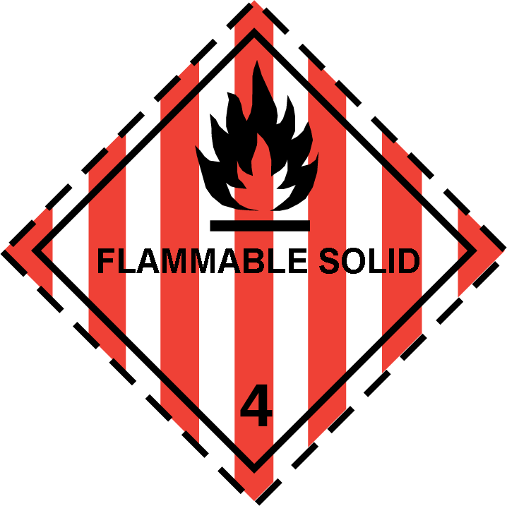
- Class 4 Flammable Solids
- Label 4
- 14.4 Packing group
- ADR, IMDG, IATA I
· 14.5 Environmental hazards: Not applicable.
- 14.6 Special precautions for user Warning: Flammable Solids.
- Hazard identification number (Kemler code): 44
- EMS Number: F-E,S-E
- Stowage Category B
· 14.7 Transport in bulk according to Annex II of
Marpol and the IBC Code Not applicable.
· Transport/Additional information:
- ADR
- Limited quantities (LQ) 1Kg
- Excepted quantities (EQ) Code: E2
Maximum net quantity per inner packaging: 30g
Maximum net quantity per outer packaging: 500g
- Transport category 2
- Tunnel restriction code D/E
· UN "Model Regulation": UN 3175 FLAMMABLE SOLID, N.O.S., SPECIAL PROVISION 640C (ETHYL METHYL KETONE (METHYL ETHYL KETONE), TOLUENE), 4, I

GB

- 15.1 Safety, health and environmental regulations/legislation specific for the substance or mixture
- Directive 2012/18/EU
- Named dangerous substances - ANNEX I None of the ingredients is listed.
- Seveso category P5c FLAMMABLE SOLIDS
- Qualifying quantity (tonnes) for the application of lower-tier requirements 5,000 t
- Qualifying quantity (tonnes) for the application of upper-tier requirements 50,000 t
- National regulations:
- Information about limitation of use:
Workers are not allowed to be exposed to the hazardous carcinogenic materials contained in this preparation. Exceptions can be made by the authorities in certain cases.
- Other regulations, limitations and prohibitive regulations
The Dangerous Substances and Explosive Atmoshere Regulations (DSEAR)
(Contd. on page 11)
SECTION 15: Regulatory information

· 15.2 Chemical safety assessment: A Chemical Safety Assessment has not been carried out.
SECTION 16: Other information
This information is based on our present knowledge. However, this shall not constitute a guarantee for any specific product features and shall not establish a legally valid contractual relationship.
The information contained in this SDS does not constitute a risk assessment, and should not replace the user's own assessment of risks as required by other health and safety legislation.

· Relevant phrases
H225 Highly flammable liquid and vapour. H226 Flammable liquid and vapour.
H304 May be fatal if swallowed and enters airways. H315 Causes skin irritation.
H319 Causes serious eye irritation. H336 May cause drowsiness or dizziness.
H361d Suspected of damaging the unborn child.
H373 May cause damage to organs through prolonged or repeated exposure.

Training hints
Make users aware of the contents of this document and train according to use and risks within your operation.
- Department issuing SDS: Product safety department.
- Contact: Sales Office in the first instance.

Abbreviations and acronyms:
ADR: Accord relatif au transport international des marchandises dangereuses par route (European Agreement Concerning the International Carriage of Dangerous Goods by Road)
IMDG: International Maritime Code for Dangerous Goods IATA: International Air Transport Association
GHS: Globally Harmonised System of Classification and Labelling of Chemicals EINECS: European Inventory of Existing Commercial Chemical Substances ELINCS: European List of Notified Chemical Substances
CAS: Chemical Abstracts Service (division of the American Chemical Society) VOC: Volatile Organic Compounds (USA, EU)
LC50: Lethal concentration, 50 percent LD50: Lethal dose, 50 percent
PBT: Persistent, Bioaccumulative and Toxic vPvB: very Persistent and very Bioaccumulative Flam. Liq. 2: Flammable liquids – Category 2 Flam. Liq. 3: Flammable liquids – Category 3
Skin Irrit. 2: Skin corrosion/irritation – Category 2
Eye Irrit. 2: Serious eye damage/eye irritation – Category 2 Repr. 2: Reproductive toxicity – Category 2
STOT SE 3: Specific target organ toxicity (single exposure) – Category 3 STOT RE 2: Specific target organ toxicity (repeated exposure) – Category 2 Asp. Tox. 1: Aspiration hazard – Category 1
GB

